WEEK 1 AUTUMN MENU
BREAD, MILK, FRUIT AND SALAD ARE SERVERD EACH DAY

WEEK 2 AUTUMN MENU
Monday | Tuesday | Wednesday | Thursday | Friday
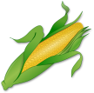  Cheesy Pasta  Sweetcorn  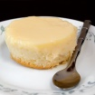 | Chicken Curry  Vegetable rice | Sausage  mashed potato  Carrots / Gravy | Hot chicken sandwich  Potato wedges  salad | Fishcake  Potato Dice  Spaghetti Hoops/Beans
Ginger syrup sponge  Custard | Apple crumble and ice cream | Chocolate Muffin | Toffee Yoghurt | Jam sponge and custard
Monday | Tuesday | Wednesday | Thursday | Friday
Pork meatballs In Tomato Sauce  Pasta  sweetcorn | Chicken wraps  Rice and salad | Mince  Cheese cobbler  Roast potatoes/Carrots/ Peas | Chees and Tomato pizza  Potato dice  Spaghetti hoops/Beans | Salmon fillet  Salad potatoes  Peas
Chocolate cake and chocolate sauce | Peach crumble and Ice cream | 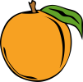  Orange muffin | Fruit yoghurt | Sticky toffee pudding  Custard
BREAD, MILK, FRUIT AND SALAD ARE SERVERD EACH DAY
WEEK 3 AUTUMN MENU
Monday | Tuesday | Wednesday | Thursday | Friday
Cowboy Casserole  Jacket Wedges | Chicken Pie  Roast potatoes  Carrots | 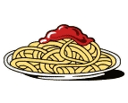  Pasta Bolognese  Garlic Bread  Sweetcorn | Sweet & Sour chicken  Vegetable rice | Fish Fingers  Potato dice  Peas
Chocolate Orange drizzle cake  Custard | 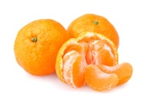  Mandarins/Jelly  Ice cream | Strawberry muffin | 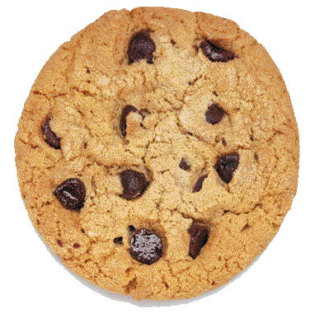  Oaty Biscuit | Eves pudding and custard
BREAD, MILK, FRUIT AND SALAD ARE SERVERD EACH DAY

