DISHES AND THEIR ALLERGEN CONTENT - ELLINGHAM PRIMARY SCHOOL

DISHES | 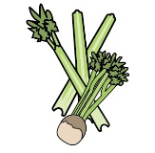 | 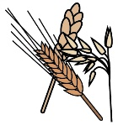 | 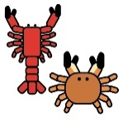 | 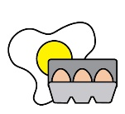 |  | 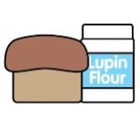 |  | 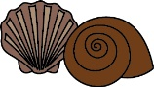 | 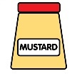 | 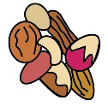 | 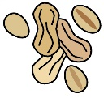 | 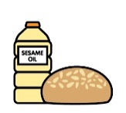
 | Celery | Cereals containing gluten | Crustaceans | Eggs | Fish | Lupin | Milk | Mollusc | Mustard | Nuts | Peanuts | Sesame seeds | Soya | Sulphur Dioxide
Salmon Fillet Wedges and Peas |  | ✓ |  |  | ✓
Pasta Bolognese Garlic Bread Sweet corn |  | ✓ |  |  |  |  | ✓
Chicken Pie Roast pots/ carrots |  | ✓ |  | ✓ |  |  | ✓
Chicken curry rice mixed veg | ✓ |  |  |  |  |  | ✓
Fishcake Potato dice and hoops / beans |  | ✓ |  |  | ✓
Chicken sandwich wedges /salad |  | ✓ |  | ✓ |  |  | ✓
Meatballs, Pasta Sweetcorn |  | ✓ |  |  |  |  | ✓
Tomato Cheese Pizza Potato dice and Hoops |  | ✓ |  |  |  |  | ✓
Cow Boy Casserole and Wedges |  | ✓

Review date: | Dec 2019 | Reviewed by: | Josie Scott |  | You can find this template, including more information at www.food.gov.uk/allergy

